# Functional Requirements

1. Referring physician is able to access RIS and place order for procedure
   1. Status: Done
   2. Affected Classes:
      1. Views:
         1. ReferralForm.fxml
         2. ReferralList.fxml
         3. AddReferredPatient.fxml
      2. Controllers:
         1. ReferralFormController.java
         2. ReferralListController.java
      3. Models:
         1. Referral.java
   3. Picture:
2. RIS is able to display worklist
   1. Status: Done
   2. Affected Classes:
      1. Views:
         1. Worklist.fxml
      2. Controllers:
         1. WorklistController.java
      3. Models:
         1. Procedure.java
         2. Appointment.java
   3. Picture:

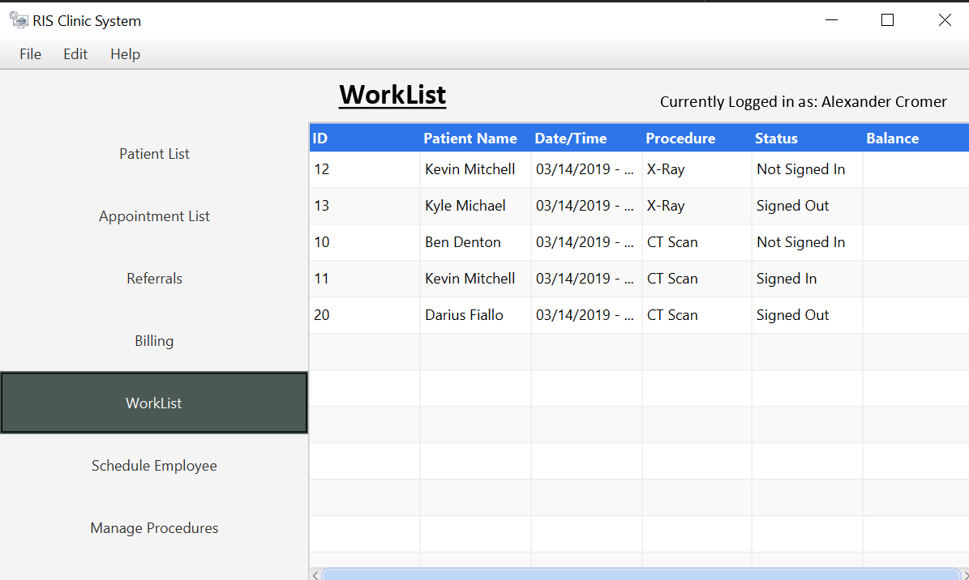

1. Actor is able to schedule appointment
   1. Status: Done
   2. Affected Classes:
      1. Views:
         1. AddAppointment.fxml
      2. Controllers:
         1. AddAppointmentController.java
      3. Models:
         1. Appointment.java
   3. Picture:
2. RIS is able to acquire an image for a patient
   1. Status: Done
   2. Affected Classes:
      1. Views:
         1. TechEntry.fxml
      2. Controllers:
         1. TechEntryController.java
      3. Models:
         1. Procedure.java
   3. Picture:
3. Radiologist can respond to patient images
   1. Status: Done
   2. Affected Classes:
      1. Views:
         1. ReportForm.fxml
         2. TechEntry.fxml
      2. Controllers:
         1. ReportFormController.java
         2. TechEntryController.java
      3. Models:
         1. Procedure.java
         2. Appointment.java
   3. Picture:
4. Radiologist can create report
   1. Status: Done
   2. Affected Classes:
      1. Views:
         1. ReportForm.fxml
      2. Controllers:
         1. ReportFormController.java
      3. Models:
         1. Procedure.java
         2. Appointment.java
   3. Picture:
5. Store technician info
   1. Status: Done
   2. Affected Classes:
      1. Views:
         1. ScheduleEmployee.fxml
      2. Controllers:
         1. ScheduleEmployeeController.java
      3. Models:
         1. ScheduleConflict.java
         2. Employee.java
   3. Picture:
6. Store patient information
   1. Status: Done
   2. Affected Classes:
      1. Views:
         1. PatientList.fxml
         2. PatientView.fxml
      2. Controllers:
         1. PatientListController.java
         2. PatientViewController.java
      3. Models:
         1. Patient.java
   3. Picture:

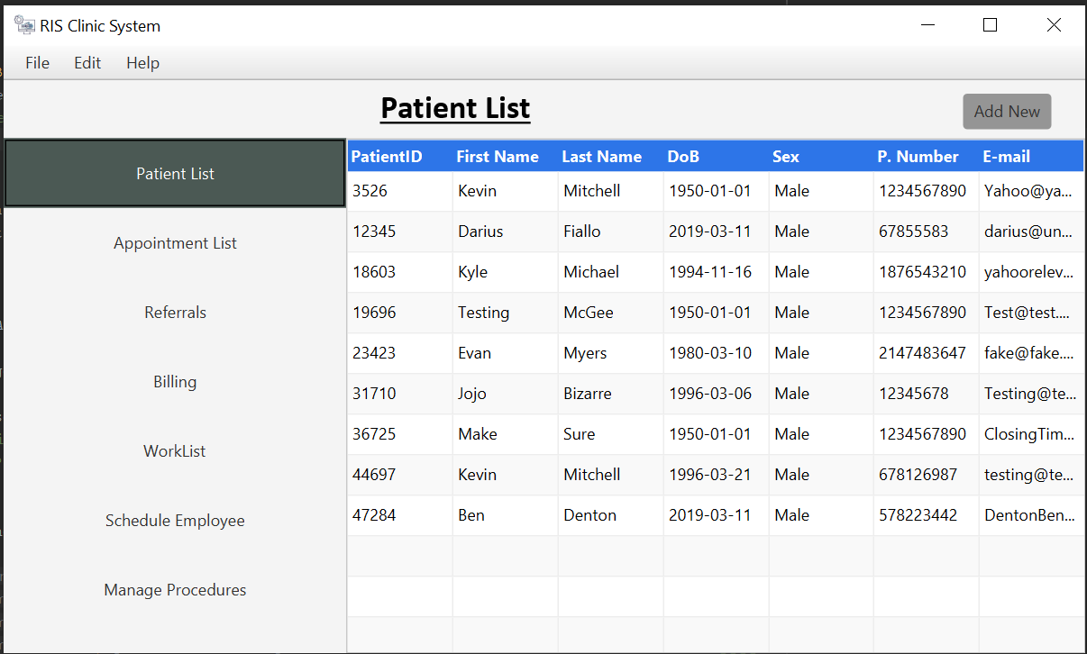

1. Require Electronic Signature
   1. Status: In Progress
   2. Affected Classes:
      1. Views:
         1. ReportForm.fxml
      2. Controllers:
         1. ReportFormController.java
      3. Models:
         1. Report.java
   3. Picture:
2. Radiologist is able to review image retrieved from database
   1. Status: Done
   2. Affected Classes:
      1. Views:
         1. ReportForm.fxml
         2. TechEntry.fxml
      2. Controllers:
         1. ReportFormController.java
         2. TechEntryController.java
      3. Models:
         1. Procedure.java
         2. Appointment.java
   3. Picture:
3. Store procedure status
   1. Status: Done
   2. Affected Classes:
      1. Views:
         1. ProcedureList.fxml
         2. AppointmentList.fxml
         3. AppointmentView.fxml
      2. Controllers:
         1. AppointmentFiles.java
         2. ProcedureListController.java
      3. Models:
         1. Appointment.java
         2. Procedure.java
   3. Picture:
4. Store images
   1. Status: Done
   2. Affected Classes:
      1. Views:
         1. TechEntry.fxml
         2. AddImage.fxml
      2. Controllers:
         1. TechEntryController.java
         2. AddImageController.java
      3. Models:
         1. Images.java
         2. Procedure.java
   3. Picture:
5. Store modality availability
   1. Status: In Progress
   2. Affected Classes:
      1. Views:
      2. Controllers:
      3. Models:
         1. ScheduleConflict.java
         2. Modality.java
   3. Picture:
6. Create and Read Reports (Radiologist)
   1. Status: Done
   2. Affected Classes:
      1. Views:
         1. ReportForm.fxml
         2. ReportList.fxml
      2. Controllers:
         1. ReportFormController.java
         2. ReportList.java
      3. Models:
         1. Report.java
   3. Picture:
7. Automatically retrieve demographic information and RP information
   1. Status: Done
   2. Affected Classes:
      1. Views:
         1. PatientView.fxml
         2. PatientList.fxml
      2. Controllers:
         1. PatientViewController.java
         2. PatientListController.java
      3. Models:
         1. Patient.java
   3. Picture:
8. RIS and PACS pull pictures, reports, and patient information properly
   1. Status: Done
   2. Affected Classes:
      1. Views:
         1. TechEntry.fxml
         2. ReportForm.fxml
         3. PatientView.fxml
      2. Controllers:
         1. TechEntryController.java
         2. ReportFormController.java
         3. PatientViewController.java
      3. Models:
         1. Procedure.java
         2. Report.java
         3. Patient.java
   3. Picture:
9. See previous exams
   1. Status: Done
   2. Affected Classes:
      1. Views:
         1. PatientView.fxml
      2. Controllers:
         1. PatientViewController.java
      3. Models:
         1. Patient.java
   3. Picture: